a. X= ABC' +A'B +A’B’

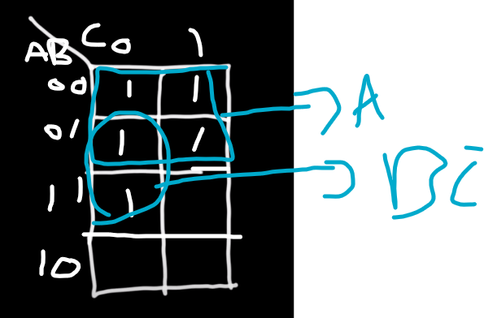

X=A+BC’

b. 𝑌 = 𝐵𝐶 + 𝐴’B’C + 𝐵𝐶’

Y=A’C + B

c. 𝑊 = 𝐵’(𝐶𝐷’ + 𝐴’𝐷) + 𝐵’C’(𝐴 + 𝐴’𝐷’)

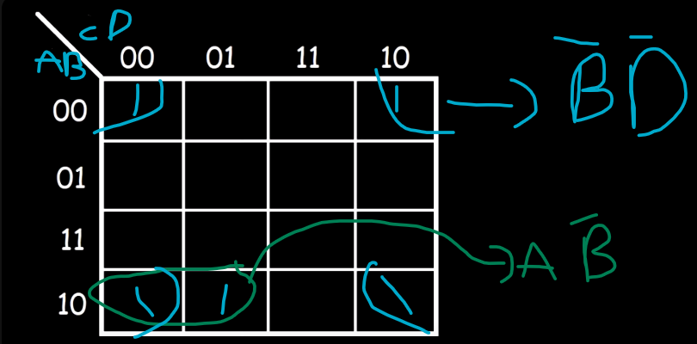

𝑊 = AB’ +B’D’

a) A’B’C’ + A’B’C + AB’C

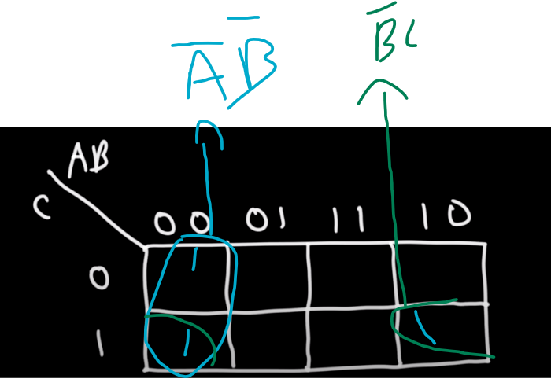

X=A’B’ +B’C

b) 𝐴𝐶 (𝐵’ + 𝐶)

x= ABC’+ AC

X= AB+AC

a. 𝐴 + 𝐵C

X = ABC +A’BC+AB’C+ABC’+AB’C’

X=A+BC

b. AB’CD + 𝐴𝐶𝐷’ + 𝐵𝐶𝐷 + 𝐴𝐵𝐶𝐷’

X= AB’CD+ABCD’+AB’CD’ + ABCD +A’BCD

X=AC+BCD

(a) (𝑋 + 𝑌')(𝑋'+ 𝑍)(𝑋 + 𝑌'+ 𝑍)(𝑋'+ 𝑌'+ 𝑍)

(X+Y’)(Y’+Z)

a) F1 =

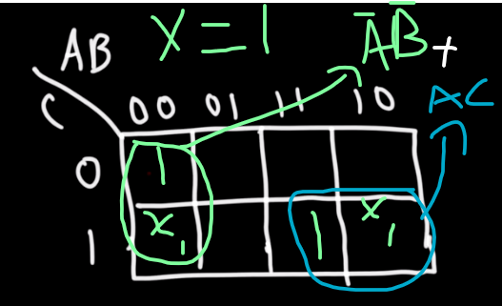

b) F2=

c) F3 =

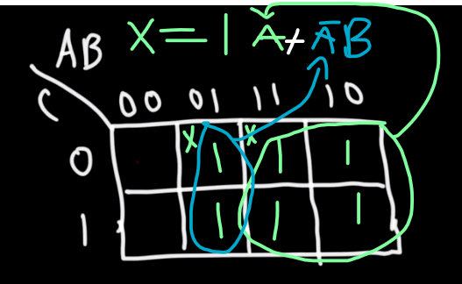

d)F4=

a) Why is A′B′ not essential?

because it's covered by more than one prime implicant

b) Why is BD′ essential?

because it's covered only by one prime implicant

c) Is A′D′ essential? Why?

Non essential, because it's covered by more than one prime implicant

d) Is BC′ essential? Why?

essential, because it's covered only by one prime implicant

e) Is B′CD essential? Why?

essential, because it's covered only by one prime implicant

f) Find the minimum sum of products

Z=A’C’+BC’+B’CD+A’D’+BD’



Z= A’B’C+CD+BC’+AC’

Z=(A+B+C)(A’+C’+D)(B’+C’+D)